The Galaxy School
IBDP BIOLOGY PRACTICALS

Name: Date:
Magnification calculation:
1. You are provided with a leaf sample, draw the diagram of its original size in the box given below
Draw the same leaf with double the magnification in the space given below

Draw the same leaf with half the magnification in the space given below

.

2. Given below is the photograph of a leaf.
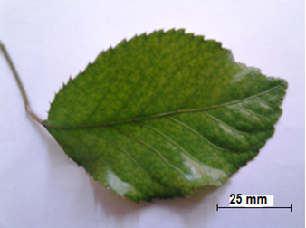
Find out the magnification of this picture
.

Calculate the actual length of the leaf

3. (a) Determine the magnification of the string of Thiomargarita cells in Figure 11, if the scale bar represents 0.2 mm .
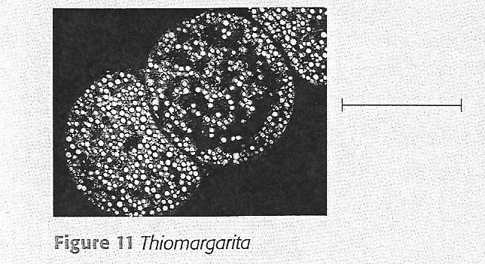
(b) Determine the width of the string of cells.

4. The magnification of human cheek cells from a compound microscope is 2000X
- Calculate how long a 20µm scale bar would be on image

- Determine the length of cheek cell
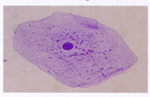

5. The diagram below shows the structure of a cell. In Figure 12 the actual length of the mitochondrion is

8µm.

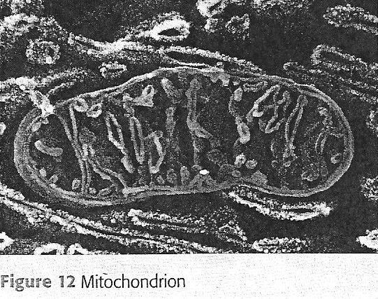

(a) Determine the magnification of this electron micrograph.

(b) Calculate how long a 5 µm scale bar would be on this electron micrograph.

(c) Determine the width of the mitochondrion.

6. Given below is the micrograph of an E.coli bacterium undergoing reproduction.

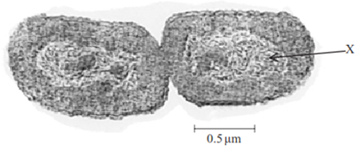

[Source: www.bio.mtu.edu/campbell/prokaryo.htm]

The scale bar represents 0.5 µm. How long are both cells in total?

5.0x10⁻⁶ m C. 5.0x10⁻⁹ m

B. 2.5x10⁻⁶ m D. 2.5x10⁻⁹ m

7. The scanning electron micrograph below shows the surface of the nuclear envelope with numerous nuclear pores.
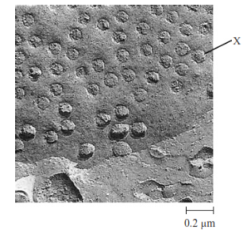

(a) Calculate the power of magnification of the image.

(b) State the diameter of the pore labeled X.

8. The below given TEM image shows a cell dividing.
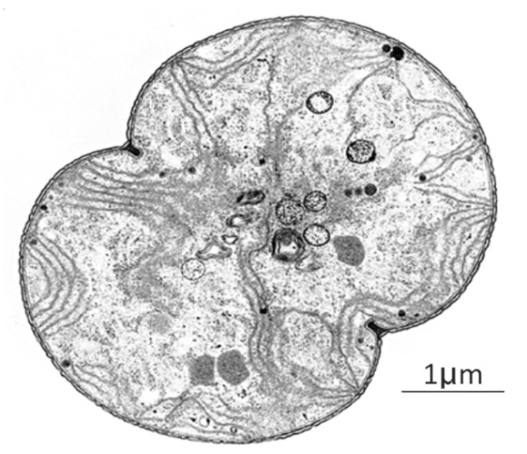

(a)What is the magnification of this image?

(b)What is the actual maximum length across this dividing cell?

9. (a) Using the width of the hen’s egg as a guide, estimate the actual length of the ostrich egg (Figure 14)
Actual width of hen egg is 45mm. (b) Estimate the magnification of the image.
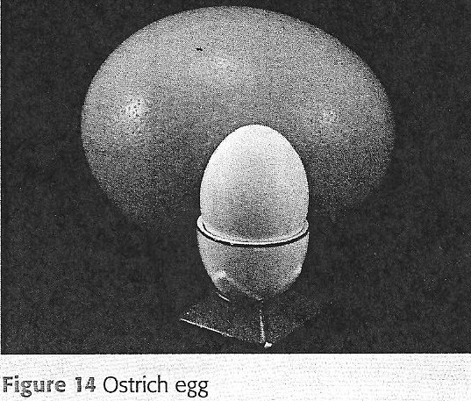

10. The diagram shows a graduated slide, with divisions of 0.1 mm viewed using an eyepiece graticule.

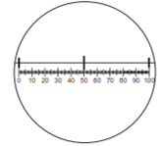

Pollen grains were grown in a sugar solution and viewed using the eyepiece graticule. Diagram 1 shows the pollen grains at first and diagram 2 shows them after four hours.

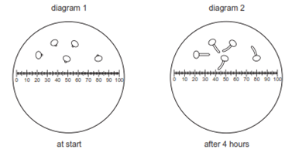

What is the growth rate of the pollen tubes?

A. 5 µmh⁻¹ B. 10 µmh⁻¹ C. 5 mmh⁻¹ D. 10 mmh⁻¹
11. A cell organelle measures 4 x 10-1mm in diameter. What is the diameter in µm?
A. 4 x 10¹ µm B. 4 x 10² µm C. 4 x 10³ µm D. 4 x 10⁴ µm
12. What is the size range for the diameters of most plant and animal cells?
A. 100 to 1 m C. 1µm to 10 µm
B. 10 µm to 100 µm D. 100 µm to 1 mm
13. In an electron micrograph, a DNA molecule appears 1 mm wide. The magnification of the micrograph is 500 000. What is the width of the DNA molecule?
A. 0.5 mm B. 2 nm C. 0.5 µm D. 2 µm

14. Using a light microscope, what determines the ability to distinguish between two points lying close together?

The magnification C. The preparation

The fixation D. The resolution

15. A student observes and draws an Amoeba, using the high power lens of a microscope. The diameter of the drawing is 100 mm. The actual diameter of the Amoeba is 100 µm. What is the magnification of the drawing?

0.001 B. 100 C. 400 D. 1000

16. What describes the features of an electron microscope?
 | Maximum magnification | Resolution / nm | Specimen
A  B  C  D | 2.5 x 10³  2.5 x 10⁴  2.5 x 10⁵  5.0 x 10⁵ | 2.5 x 10²  5.0 x 10⁻¹  5.0 x 10⁻¹  2.5 x 10² | Dead  Living  Dead  Living

17. The diagram shows two cells, a bacterial cell and a plant cell.
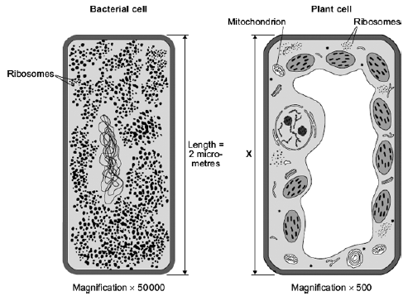
Both cells are drawn the same length, but the magnification of each cell is different.
The real length of the bacterial cell is 2 micrometres.
Calculate the real length, X, of the plant cell. Give your answer in micrometres.
Show clearly how you work out your answer.

X = ........................................ micrometres

18. The drawing shows a white blood cell ingesting a bacterium.

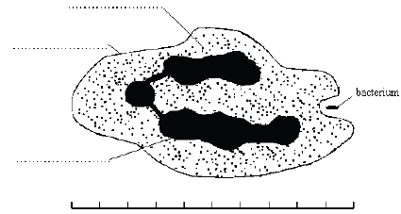
(i) Use words from the list given below to label the parts of the white blood cell.

cell membrane cell wall cytoplasm nucleus vacuole

(ii) The scale shows that the white blood cell is 10 micrometres long.
How long is the bacterium? Show your working.

................... micrometres

19. The photograph shows part of the surface of a plant root. This part of the root is covered
with hundreds of structures like the one labelled X.
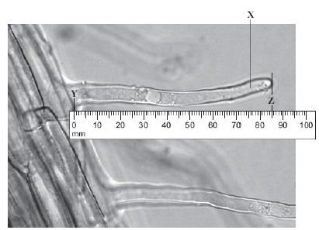
(a) What is the name of structure X?
Draw a ring around one answer.

Root hair stoma villus

(b) (i) Use the scale to measure the length Y–Z on the photograph.

On the photograph, length Y–Z = .................................... mm.

(ii) The photograph shows the root magnified 100 times.
Calculate the actual length Y–Z.

Actual length Y–Z = ........................................mm.

20. Fig. 1.1 and Fig. 1.2 show the external features of two ‘worms’, A and B. These worms belong to two
different groups of invertebrates.
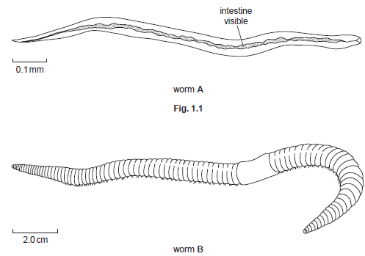
Fig. 1.2
(a) (i) Calculate the actual length of worm A.
Working

actual length of worm A. ...........................................................................................

(ii) Calculate how many times worm B is larger than worm A.
Working

answer ...................................

